Impact of Westward Expansion on Native Americans
Smithsonian Center for Education and Museum Studies
Question: Analyze the effectiveness of The US Government attempts to assimilate Native Americans in the latter half of the 19th century.
Your first paragraph should consist of context and thesis only. –DO NOT INTRODUCE DOCUMENTS IN THE INTRODUCTION!
Historical Context- To earn this point, the response must relate the topic of the prompt to broader historical events, developments, or processes that occur before, during, or continue after the time frame of the question. This point is not awarded for merely a phrase or reference.
Thesis- To earn this point, the thesis must make a claim that responds to the prompt rather than restating or rephrasing the prompt. The thesis must consist of one or more sentences located in the first paragraph as the last sentence. It should list the three topics you will use to support your argument.
Evidence- To earn one point, the response must accurately describe — rather than simply quote — the content from at least three of the documents. Use HIPPO. It is better to go into ONE element of HIPPO in depth than to rush through all of it.
Evidence-To earn a second evidence point, the response must accurately describe — rather than simply quote — the content from at least six documents. In addition, the response must use the content of the documents to support an argument in response to the prompt.
NEVER start a sentence with “Document A says…” or “As seen in Document A….” This will make your essay be about the documents…it is about the prompt and your argument. Simply describe it and label it (Doc.x).
Analysis- To earn this point, the response must explain how or why (rather than simply identifying) the document’s point of view, purpose, historical situation, or audience is relevant to an argument about the prompt for each of the three documents sourced.
Complex Understanding- One Point- A response may demonstrate a complex understanding in a variety of ways, such as:
- Explaining nuance of an issue by analyzing multiple variables
- Explaining both similarity and difference, or explaining both continuity and change, or explaining multiple causes, or explaining both cause and effect
- Explaining relevant and insightful connections within and across periods
- Confirming the validity of an argument by corroborating multiple perspectives across themes
- Qualifying or modifying an argument by considering diverse or alternative views or evidence This understanding must be part of the argument, not merely a phrase or reference.

Document A
Excerpt from a report by E.A. Swan, U.S. Indian agent, to commissioner, August 28, 1882.

Swan to Commissioner
The Indians here I find are not very unlike white people, some are willing to labor for what they have and others think they ought to be supported in their idleness. It has been my aim from the first to put a premium on industry, and condemn indolence in any and all. I find the complaining and fault-finding usually belong to this class. The Indians here as a rule learn the trades easily, perhaps more readily even than farming. There are goodly numbers who can perform service in the shops or mills, and show evidence of rapid advancement in mechanism.

Source: United States, Interior Department, Report of the Secretary of the Interior, vol. 2 (Washington, D.C.: Government Printing Office, 1882), 199–202, NADP Document D 54.

Document B
Telegram to Washington, D.C.
Nov. 15, 1890
"Indians are dancing in the snow and are wild and crazy. I have fully informed you that the employees and the government property at this agency have no protection and are at the mercy of the Ghost Dancers. ... We need protection and we need it now ...nothing [short] of 1000 troops will stop this dancing."
Dr. Daniel F. Royer, Agent,
Pine Ridge Agency

Document C
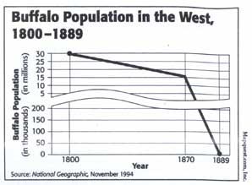

Document D
"Reformers interested in Indian Affairs met each year from 1883 to 1916 at Lake Mohonk, New York, to discuss Indian matters and to make recommendations. had tremendous impact on the formulation of federal policy
Excerpt from the Second Annual Address to the Public of the Lake Mohonk Conference in Philadelphia, 1884, 3–7, 13–22.
1st. Resolved, That the organization of the Indians in tribes is, and has been, one of the most serious hindrances to the advancement of the Indian toward civilization, and that every effort should be made to secure the disintegration of all tribal organizations; that to accomplish this result the Government should . . . cease to recognize the Indians as political bodies or organized tribes. . . .
4th. Resolved, That all adult male Indians should be admitted to the full privileges of citizenship by a process analogous to naturalization, upon evidence presented before the proper court of record of adequate intellectual and moral qualifications. . ..
6th. Resolved, That . . . our conviction has been strengthened as to importance of taking Indian youth from the reservations to be trained in industrial schools placed among communities of white citizens. . ..
14th. Resolved, That immediate efforts should be made to place the Indian in the same position before the law as that held by the rest of the population.

Document E
Group of Non-Native Men, Government Agents with Sacks of Food Rations to Be Distributed, Circles by Seated Group in Native Dress; Log Buildings, Tipis, and Corral Nearby (no date) by Taylor E. James, Photographs of American Indians and Other Subjects, 1840s–1960s, Smithsonian Institution National Anthropological Archives.
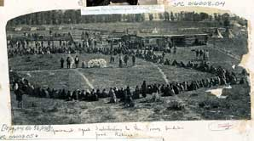
Document F
Three Lakota Boys, Carlisle Indian Industrial School, ca 1900.
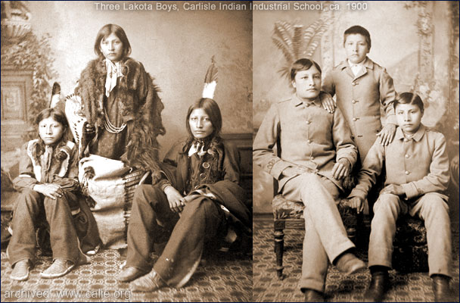

Document G
Two descriptions of the Wounded Knee Massacre
Troops began moving from tipi to tipi, confiscating knives and axes from the women, sometimes seizing a rifle. A medicine man began to dance. "Do not fear," he told the warriors,"but let your hearts be strong. Many soldiers are about us and have many bullets, but I am assured the bullets cannot penetrate us."
Suddenly, scooping up a handful of dirt, he tossed it scattering in the air, and with eyes turned toward heaven, implored the Great Spirit to scatter the soldiers likewise.
Charles Allen In the West that Was. First Bison Books, Lincoln NE 1998. Print

"Almost simultaneously with him throwing a handful of dirt into the air, soldiers tried to disarm a man who was deaf. And he hung on to his rifle and they kind of struggled over it and it went off. These two things happened at the same time and -- bang -- I mean, it just blew everything up."
Robert Utley, Life and Times of Siting Bull, Ballentine Books, New York. 1993. Print (Google Books)

